My Letter
To Johnny Carson
March 2, 2001
Johnny Carson
c/o Carson Productions Group
3110 Main St.
Suite 200
Santa Monica, CA 90405
Mr. Carson:
Hello.
I am originally from Norfolk, Nebr., graduated from NHS in 1973. Recently I had a chance to listen to the tape of your interview with attorney Jim Garrison. I don't recall watching the live interview, but very well could have as watching your show before bed was our regular routine, as it was for many others.
As a fellow Norfolkan, I am curious as to why you treated Garrison as you did. I probably will not get the chance to contact you twice, so I will be frank right away. You sounded as if you were acting as a spokesman for someone else. Really. Were you protecting the real killers of Kennedy?
Of course, you were. What else can I say, but that it is obvious now with almost forty years of perspective. The Warren Commission was a joke and Garrison was on to something. Something frightening to be sure. But why did you have so much allegiance to the plotters and none to your dead president? Because he could not pay you from the grave? Is it as simple as that?
Thanks in part to you we have been forced to live in Disneyland since 1963, where everything is unreal, everything entertainment and illusion.
Please tell me, as I will never know myself: Is wealth and power worth the sublimation of the truth?
Thank you for your time.
Sincerely,
Mike Palecek
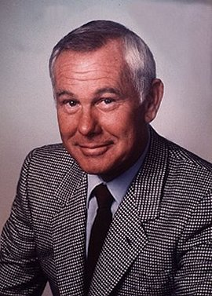
Johnny Carson's Response:
March 9, 2001
Mike Palecek
702 6th Avenue
Sheldon, Iowa 51201
Dear Mr. Palecek,
I'm sending you a copy of a letter I recently received to make you aware that some ignorant asshole is sending out letters over your signature.
You should look into this.
Sincerely,
Johnny Carson

